Eg: String_Eg98
Core Rule (One line, very important)
In Java, instance variables and static variables of ANY reference type get the default value null if no object is assigned to them.

Your example
class A {
StringBuilder sb; // instance variable
}
What exactly is sb?
- sb is a reference variable
- Type: StringBuilder
- It can store the address of a StringBuilder object
- Right now, it stores nothing

When does JVM assign null?
When you do:
A obj = new A();
JVM does two things:
1️⃣ Creates an object of class A
2️⃣ Initializes all instance variables of A with default values
So memory becomes:
Heap
-------------------------
| obj → A object |
| sb = null |
-------------------------

Why null?
Because:
- JVM must put some value
- Reference types cannot store garbage
- So JVM uses null to mean:
“This reference is not pointing to any object”

This applies to ALL reference types
Let’s prove it with examples 👇

1️⃣ Any Class Type
class B {}

class A {
B b;
}
After new A():
b = null
✔ Because B is a reference type

2️⃣ String
class A {
String s;
}
After new A():
s = null
✔ String is also a class → reference type

3️⃣ Array
class A {
int[] arr;
}
After new A():
arr = null
✔ Arrays are objects in Java

4️⃣ Interface Reference
interface I {}

class A {
I ref;
}
After new A():
ref = null
✔ Interface variables are references to implementing objects

What is NOT included ❌
Local variables
void test() {
StringBuilder sb;
}
- Local variables get NO default value
- Compiler forces initialization

Primitive vs Reference (Quick contrast)
Type | Default value
int | 0
boolean | false
double | 0.0
char | '\u0000'
Any reference type | null

Very important clarification
❌ Wrong thought
sb is null because StringBuilder object is not created
✅ Correct thought
sb is null because JVM initializes unassigned reference variables to null
The reason is JVM initialization rule, not absence of object creation.

Final mental model (lock this 🔒)
- Reference variable = address holder
- Object = actual data in heap
- null = “no address assigned”

One-line interview answer
In Java, all instance and static variables of reference types are automatically initialized to null if no object is assigned, regardless of whether the type is String, array, interface, or any user-defined class.

✔ Case 2: Object is created and reference points to it
StringBuilder sb = new StringBuilder();

Step-by-step breakdown
1️⃣ StringBuilder sb; (conceptually)
- sb is a reference variable
- It can hold the address of a StringBuilder object
- At this moment (if instance/static), default value would be null

2️⃣ new StringBuilder();
- JVM creates a real object in heap memory
- That object has:
  - internal character array
  - capacity
  - length = 0 (empty content)
Memory (conceptual):
Heap
------------------------------
| StringBuilder object |
| value = char[16] |
| length = 0 |
------------------------------

3️⃣ Assignment happens
sb = (address of StringBuilder object)
Now:
Heap
----------------------------------
| sb → StringBuilder object |
----------------------------------

What is the value of sb now?
- sb holds a valid memory address
- So sb is NOT null
- Methods can be safely called
sb.append("hi"); // works fine

Why we say “default value is NOT null” here
This sentence needs precision 👇
❌ Wrong interpretation
The object’s default value is not null
✅ Correct interpretation
The reference variable no longer holds its default value (null), because it now points to an object

⚠️ Very important distinction (lock this in)
🔴 Objects do NOT have default values
- Objects are created using new
- They are initialized using constructors
- Their state depends on constructor logic
Example:
new StringBuilder();
- length = 0
- capacity = 16
These are constructor-initialized values, NOT default values

🟢 Variables DO have default values
Only these get default values:
- Instance variables
- Static variables
Example:
class A {
StringBuilder sb; // default = null
int x; // default = 0
}

Why this distinction matters (real clarity)
Think like this:
Thing | Gets default value?
Instance variable | ✅ Yes
Static variable | ✅ Yes
Local variable | ❌ No
Object | ❌ No

Empty object vs null reference (very common confusion)
StringBuilder sb1 = null;
StringBuilder sb2 = new StringBuilder();
sb1 | sb2
Reference only | Reference + Object
Value = null | Value = address
❌ Method call → NPE | ✅ Method call works
No object exists | Object exists (empty)

One-line golden rule
Default values belong to variables; object state belongs to constructors.

Interview-ready explanation
When an object is created, the reference variable no longer holds its default value null. Objects themselves do not have default values; their state is initialized by constructors. Default values apply only to variables, not to objects.

Eg:String_Eg99
// go through the code

Eg: String_Eg100
// go through the code

Eg: String_Eg101
// go through the code.

Eg: String_Eg102
// go through the code

Eg: String_Eg103
// Go through the code

Eg: String_Eg104
// go through the code
Eg: String_Eg105
// go through the code

Eg: String_Eg106
// go through the code

Eg: String_Eg107
// go through the code

Eg: String_Eg108
// go through the code

Eg: String_Eg109
// go through the code

Eg: String_Eg110
// go through the code

Eg: String_Eg111
// go through the code

Eg: String_Eg112
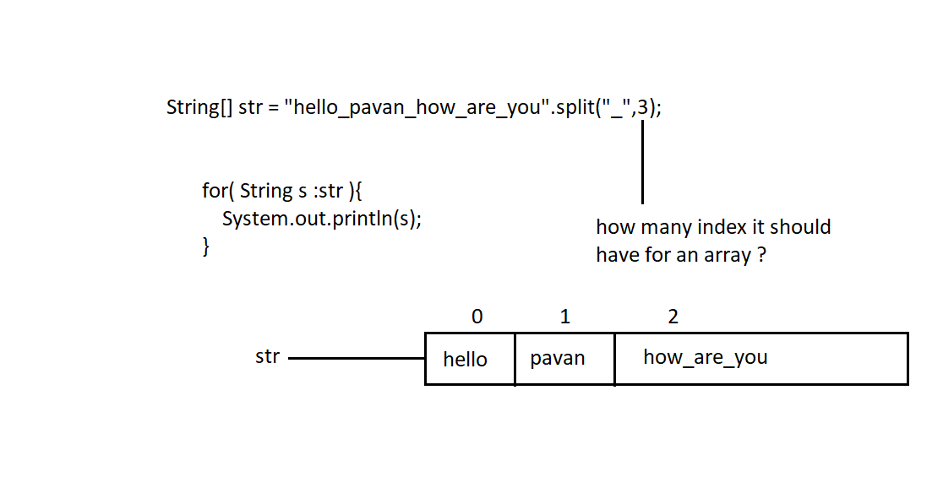
If we don’t give array size, wherever “_” is found in the string object, the array will have that many no of index’s.

Which of these classes have delete() and reverse() methods?
A) java.lang.String
B) java.lang.StringBuilder
C) java.lang.StringBuffer

Answer:
B) java.lang.StringBuilder
C) java.lang.StringBuffer

Explanation (Important for exams & interviews):
String class is immutable
Its content cannot be changed
So it does NOT have delete() or reverse() methods
StringBuilder class is mutable
It allows modification of the same object
Hence it has methods like:
delete()
reverse()
append()
insert()
StringBuffer class is also mutable
It is thread-safe (synchronized)
It contains all methods of StringBuilder
So it also has:
delete()
reverse()

Important Note (Very Common Question):
Methods present in StringBuilder are also present in StringBuffer

